Mental Health Commissioning Review 2020
- Supporting Recovery in the Community

Delivering the Right support at the Right time and in the Right place

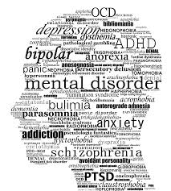

The wider determinants of health are the social, economic and environmental conditions in which people live that have an impact on mental health and well-being. They include income, education, access to green space and healthy food, the work people do and the homes they live in.

Adult social care seeks to recognise community assets, strengthen local networks and integrated pathways, and create better access to community resources.

The key challenges for mental health services in 2020 are:
- To respond to the continuing rise in demand for health and social care services at a time when government funding is decreasing.
- To enhance health, wellbeing and resilience with a preventative approach that embodies the ‘wellbeing principle’.
- Delivering the right level and type of support at the right time and in the right place to enable people to maintain their wellbeing and independence.
- To pave the way for greater health and social care integration in the delivery of assessments, treatment and support for recovery.

- To transform and improve the support offer within available resources.

- Executive Summary
Background to Review
This review has been commissioned to provide an independent analysis of local community- based support provision for adults with mental ill-health. The remit was to conduct an assessment of the current services based on their overall cohesion as part of a recovery pathway, rather than a detailed analysis of each of the services performance.

Both academic and clinical thinking have concluded that the key determinants of health and wellbeing require a holistic consideration of all aspects of a person’s life, and therefore a co-ordinated support offer is required to fully enable someone’s recovery and to maintain their well-being.
Recovery support services in Harrow and the commissioning of such in recent years have evolved in silos, due to the absence of a single strategic and co-ordinated approach to commissioning planning at a whole system level.
It should be noted that the review commenced prior to the Covid19 pandemic, and has been completed during this period which has meant some limitations on access to staff and data.
Scope of Review
The review has considered both LBH commissioned (directly or delegated), and the in-house directly provided community support services for working age adults aged 18-65 with mental ill-health.

Outside of scope of this review were the following aspects:
- CNWL assessment and treatment direct delivery services
- In-patient and NHS rehab services
- Services for older adults 65+
- CAMHS
- Advocacy
- IAPT Counselling

The focus for the review was to determine
- The efficiency and effectiveness of the current recovery pathway experienced by people with mental health support needs; and
- The extent to which both the Council directly provided and commissioned services maximised people’s independence and social inclusion

Needs Analysis
Public health has been commissioned to undertake a Joint Strategic Needs Assessment for mental health, where initial findings are referenced accordingly in this report, and further work will need to be developed to inform future commissioning planning.
Therefore, the initial data which has been used in order to inform the projected demand for local provision, has largely been based on service activity and national statistics on indicative areas of service need.

Recovery & Resilience Service model-Tiered approach
A tiered approach to service delivery enables people to be safe at whatever stage of their recovery, and importantly prevent people from reaching crisis point which could otherwise require another period of hospitalisation. The expectation is that the majority of a population should have access to support at Tier 1 to support self-resilience through the provision of low-level advice and support, or access to IAPT counselling through community organisations.

Feedback from Service Users and Family Carers
This review of the recovery pathway considered the key life components of Where I live; Being Part of my Community; Support to care; Information and advice; Physical health and Lifestyle; and Access to Learning and Employment through conversations with experts by experience and support providers.

The key findings from these initial discussions and feedback from the focus group participants are summarised in section 2.4 of the main report, and have been used to inform the recommendations in this report.

Discussions were also held with Harrow Rethink support group, CNWL Carer assessment workers and Harrow carers centre. Following the onset of the covid-19 pandemic, a questionnaire was distributed where possible by email to Family Carers across the borough in early April 2020, and facilitated through the identified support groups or organisations. Whilst the overall response was low given the circumstances at the time, there were some important themes reported from those that were able to respond, namely:
- Lack of future planning for loved ones, for when the family are unable to continue to provide support
- The main source of advice and support is other carers through lived experience
- The notional allocation of a set amount following a Carers assessment does not reflect the changing level of support needed

3. The Case for Change
The way in which services have evolved within the recovery pathways in Harrow, has created ‘blockages’ and delays in accessing services for those requiring support in a timely manner. This means that rather than a service delivery focussed to promote recovery, the system appears to have unintentionally created long term dependency due to lack of the right support being available at the right time, or having the required officer capacity to ensure the continued impetus to move on to the next stage of independence.
The majority of the current provision and investment is therefore focussed at maintaining people with high levels of dependency, as opposed to building self-resilience at a community level and then providing a varied support network that people can return to when they need additional support.
Recommendations
The recommendations in this report are grouped around the following 5 key findings:
- There is a need for a whole system approach to the commissioning of mental health support
- There should be a redesign of the supported accommodation portfolio to better support people moving to more independence
- The focus on delivering building based activities has limited people’s ability to access personalised support
- There is an underdeveloped recognition of the value of the voluntary sector
- The current support offer to Carers would benefit from closer review to ensure that it is fully aligned with the principles contained within the Care Act 2014

The intention is to co-produce a shared mental health strategic vision for Harrow, which promotes social inclusion and support for recovery, through an integrated and improved holistic service offer.

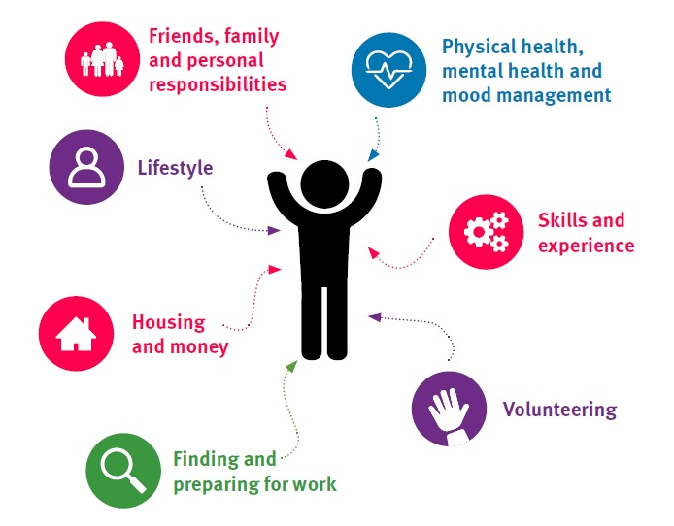

The impact of Covid19
The coronavirus pandemic and the subsequent lockdown initiated by the UK government impacted amongst other things, on the completion of some of the areas that the review had sought to explore. Whilst changing to new ways of connecting through teleconference and phone calls enabled some aspects to proceed, some areas will require further exploration with stakeholders prior to the implementation of proposals.
Increasingly over the past few months, it is now also becoming recognised nationally that the effect of social distancing, lockdown, the loss of loved ones to the disease, the increased pressure and daily risk to keyworkers, growing unemployment, and the continued daily media reporting on the topic, are inevitably having an effect on the mental health of the general population.
The pandemic is therefore occurring within an already increased prevalence of mental health issues in recent years, with researchers indicating the likelihood of additional adverse effects on brain function in patients infected with Covid19.
In Harrow, adult support services are currently being provided in alternative ways that maintains social distancing and to safeguard both staff and people accessing the services. For some people this has meant growing new support networks outside of social services such as through social media to avoid isolation and to access help, but others will certainly have struggled with the sudden and complete change in routine. On a positive note, lockdown has also led to an increased mobilisation of community action and growth in self-resilience.
Therefore, the review recommendations contained in this report now need to be considered within this new context. The building focussed support will need to be considered within the continued requirement on social distancing for the foreseeable future. This means that the previous service model for community support has to change, to ensure that people can still access some form of support to maintain their wellbeing.
The impact of the pandemic on the general public’s mental health and wellbeing will also inevitably see a rise in referrals for common mental health disorders as people try to come to terms with the ‘new normal’, and the capacity of community based support will need to anticipate this increase and respond proactively to support and signpost people at the earliest opportunity.
The response ultimately needs to form part of a whole system approach to manage what is likely to require population-based commissioning focussing on both prevention and recovery.

